**Lecture-09**

**Government**

A government is the system by which a state or community is governed. Government comprises the set of legal and political institutions that regulate the relationships among members of a society and between the society and outsiders. These institutions have the authority to make decisions for the society on policies affecting the maintenance of order and the achievement of certain societal goals. Within the modern nation-state, government operates at many different levels, ranging from villages to cities, counties, provinces, and states.

**Different Forms of Government**

There are three major types of government

**1. Monarchy**: -a King, Queen, or Emperor holds supreme power

1. *Absolute monarchy*- rules all aspects of society

-few exist in the world today (Saudi Arabia)

1. *Constitutional Monarchy-*

**-**share government power with elected officials

(Great Britain, Japan, Sweden, Netherlands)

**2. Dictatorship:**

* A country ruled by a single leader. The leader has not been elected and may use force to keep control.
* In a military dictatorship, the army is in control.

*Example:* Iraq under Saddam

**3. Oligarchy: - rule by a small group**

**-**A government in which a few people such as a dominant clan or clique have power.

-attain power through wealth, military power, social position, or a combination of these

-communist governments are most often associated with Oligarchies

-few exist today: Cuba, Vietnam, N. Korea, and China

-the Communist Party does often get individuals elected to office

**5**. **Autocracy**

- A form of government in which the political power is held by a single, self-appointed ruler.

- A single-party state is a type of government in which a single party forms the government and no other parties are permitted to contest elections and are prevented from legally getting power.

**7. Republic**

Rule by a form of government in which the people, or some significant portion of them, have supreme control over the government and where offices of state are elected or chosen by elected people.

1. [**Constitutional republic**](http://en.wikipedia.org/wiki/Constitutional_republic)**:** Rule by a government whose powers are limited by law or a formal constitution, and chosen by a vote amongst at least some sections of the populace.

*Examples:* The [United States](http://en.wikipedia.org/wiki/United_States), [South Africa](http://en.wikipedia.org/wiki/South_Africa), [India](http://en.wikipedia.org/wiki/India), etc.

1. [**Parliamentary republic**](http://en.wikipedia.org/wiki/Parliamentary_republic)**:** A republic, like [India](http://en.wikipedia.org/wiki/India), [Singapore](http://en.wikipedia.org/wiki/Singapore) and [Poland](http://en.wikipedia.org/wiki/Poland), with an elected head of state, but where the head of state and head of government are kept separate with the head of government retaining most executive powers, or a head of state akin to a head of government, elected by a parliament.
2. [**Federal republic**](http://en.wikipedia.org/wiki/Federal_republic)**:** A federal union of states or provinces with a republican form of government. *Examples:* Argentina, [Austria](http://en.wikipedia.org/wiki/Austria), [Brazil](http://en.wikipedia.org/wiki/Brazil), [Germany](http://en.wikipedia.org/wiki/Germany), [India](http://en.wikipedia.org/wiki/India), [Russia](http://en.wikipedia.org/wiki/Russia), and [Switzerland](http://en.wikipedia.org/wiki/Switzerland)
3. [**Islamic Republic**](http://en.wikipedia.org/wiki/Islamic_Republic)**:** Republics governed in accordance with Islamic law. *Examples:* include [Afghanistan](http://en.wikipedia.org/wiki/Afghanistan), [Pakistan](http://en.wikipedia.org/wiki/Pakistan), and [Iran](http://en.wikipedia.org/wiki/Iran).
4. **Socialist Republic:** Countries like [China](http://en.wikipedia.org/wiki/People%27s_Republic_of_China) and [Vietnam](http://en.wikipedia.org/wiki/Vietnam) are meant to be governed for and by the people, but with no direct elections. The term *People's Republic* is used to differentiate themselves from the earlier republic of their countries before the people's revolution, like the Republic of China and Republic of Korea.

**9. Anarchy**

* Anarchy is a situation where there is no government. This can happen after a civil war in a country, when a government has been destroyed and rival groups are fighting to take its place.
* Anarchists are people who believe that government is a bad thing in that it stops people organizing their own lives.

*Example:* Afghanistan

**10. Capitalist**

* In a capitalist or free-market country, people can own their own businesses and property. People can also buy services for private use, such as- healthcare.
* But most capitalist governments also provide their own education, health and welfare services.

**11. Communist**

* In a communist country, the government owns property such as businesses and farms.
* It provides its people's healthcare, education and welfare.

**12. Democracy: *Democracy*- rule by the people (government by the many)**

-power lies with the people

**a. Direct democracy**

**-**the people govern themselves by voting on issues

**b. Representative democracy**

-the people elect representatives to make decisions for them

-often referred to as a ***Republic***

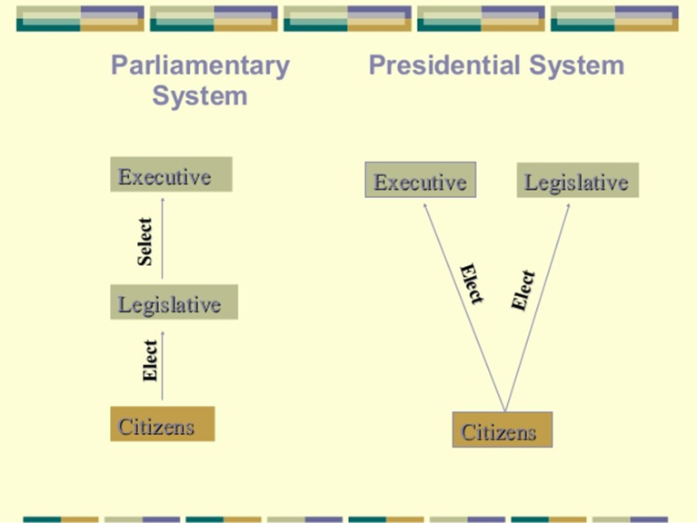

**Government system of Bangladesh**

The **Government of Bangladesh** (Bengali: বাংলাদেশ সরকার *Bangladesh Sôrkar* **GOB**) is led by the Prime Minister, who selects all the remaining Ministers. The Prime Minister and the other most senior Ministers belong to the supreme decision-making committee, known as the Cabinet. **The** **Government has three branches; the Executive branch, the Legislative branch and the Judicial branch.**

* The Constitution of the People’s Republic of Bangladesh is the constitutional document of Bangladesh. It was adopted on 16 December 1972. It provides the framework of the Bangladeshi republic with a **parliamentary government**, **fundamental human rights** and **freedoms**, an **independent judiciary**, **democratic local government** and a **national bureaucracy**. The constitution includes references to **socialism**, **Islam**, **secular democracy** and the **Bengali language**. It commits Bangladesh to “contribute to international peace and co-operation in keeping with the progressive aspirations of mankind”.

**Main office holders**

|  |  |  |  |
| --- | --- | --- | --- |
| **Office** | **Names** | **Party** | **Since** |
| **President of Bangladesh** | **Abdul Hamid** | **Awami League** | **24 March 2013** |
| **Prime Minister of Bangladesh** | **Sheikh Hasina Wazed** | **Awami League** | **6 January 2009** |
| **Speaker of the Parliament** | **Shirin Sharmin Chaudhuy** | **Awami League** | **30 April 2013** |
| **Chief Justice of Bangladesh** | **Syed Mahmud Hossain** | **Nonpartisan** | **2 February 2018** |

**Head of State**

* The President is the Head of State, a largely ceremonial post.
* The real power is held by the Prime Minister, who is the head of government.
* The president is elected by the legislature every five years.
* As head of the state, the president can grant pardon to a man sentenced to death penalty or lessen the punishment.
* In some cases, it also performs some legislative and judicial functions.

**Organ of the Government**

The Government has three branches;

1. the Executive branch,
2. the Legislative branch
3. the Judicial branch

**The Executive branch**

* **Prime Minister**

The prime minister is ceremonially appointed by the president, commanding the confidence of the majority of the MPs. The cabinet is composed of ministers selected by the prime minister and appointed by the president.

* **Cabinet**

The executive administrates the country and executes the laws, passed by the legislature. It maintains the internal law and order in the country. It also maintains relationship with foreign countries. It works for defense, liberty and sovereignty of the country.

* **Agencies**

The executive calculated the income and expenditure of the government. It also performs various public welfare services such as; education, agriculture, establishment of industry, trade & commerce, land reform, tax and revenue collection. Beside this, it also accepts and implements various development projects.

**The Legislative branch**

* The legislature of Bangladesh is unicameral.
* The 300 members are elected by universal suffrage at least every 5 years.
* It consists of 350 members at present. There is universal suffrage for all citizens at the age of 18.
* "On 16 May 2004, the Jatiyo Sangsad (the National Parliament) passed the 14th constitutional amendment to reintroduce quotas for women (article 65)
* The 10th Parliament had its first sitting on 25 January 2009. Currently there are 350 members of the house of which 50 memberships are reserved for women.

**The Judicial branch**

* **Supreme Court**

The highest judiciary body is the Supreme Court. Until recently, Chief Justice and judges were recommended by the Prime Minister and formally appointed by the President.

The Supreme Court has now judiciary and administrative authority over all lower courts in the country.

* **District Courts**
* **Specialized Courts and Tribunals**